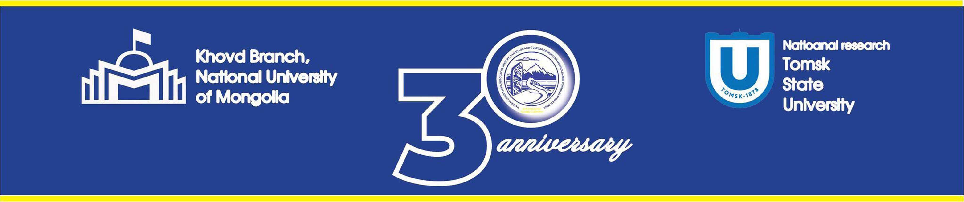

CERTIFICATE OF PARTICIPATION

Is given to

Vinogradova Natalia

For active participation of the XVI International Scientific Conference “Natural conditions, resources,
history, language and culture of Western Mongolia and consolidated regions”, hosted by theKhovd
branch of National University of Mongolia and National research Tomsk State Univcreity of Russia.

Khovd branch of National University of Mongolia, Khovd, Mongolia.
29-30 September, 2023

